**Software engineering for AI**

**techniques**

**Lab assignment**

NAME :K.Nithin sai

REG.NO : 192124024

DAY : 02

SUB CODE : CSA1001

FAC NAME : DR : MARY VALENTINA

1. Draw a USE-CASE diagram for Online Railway Reservation System using CASE tools.

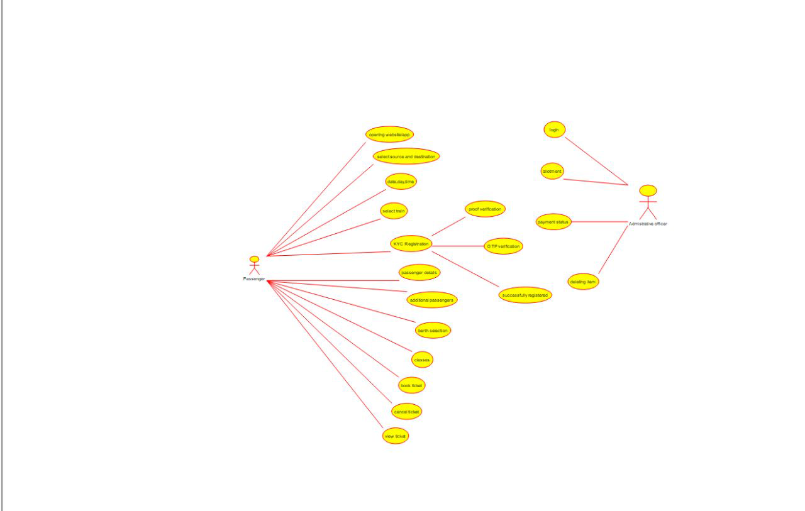

1. Draw a USE-CASE diagram for Hospital Management System using CASE tools.

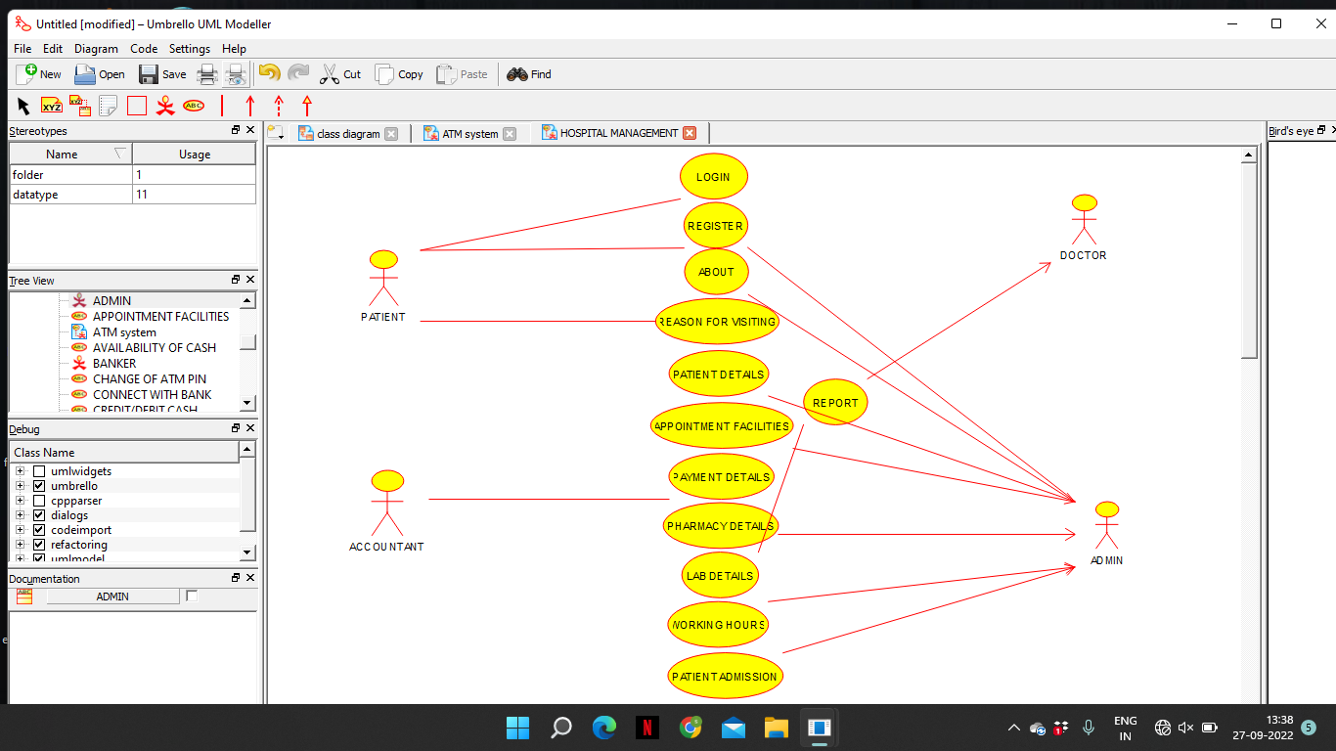

1. Draw a USE-CASE diagram for ATM System using CASE tools.

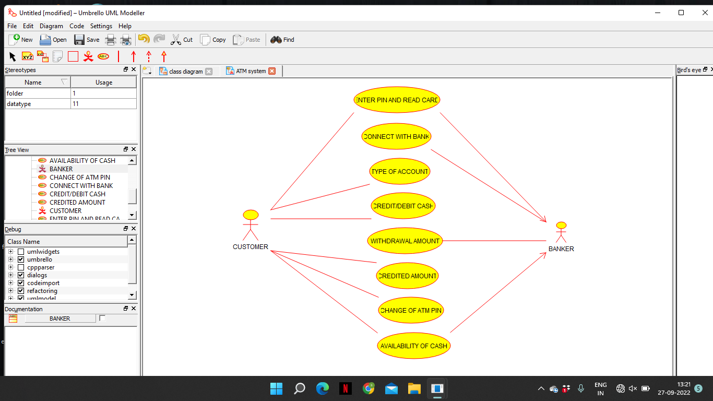

4.Draw a USE-CASE diagram for Online Shopping System using CASE tools

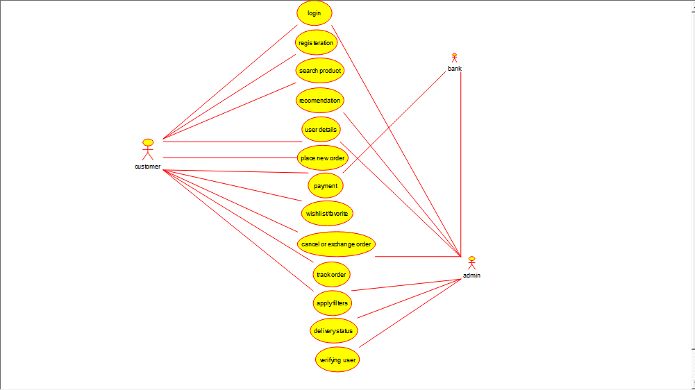

5.Draw a USE-CASE diagram for Online Airline Reservation System using CASE tools.

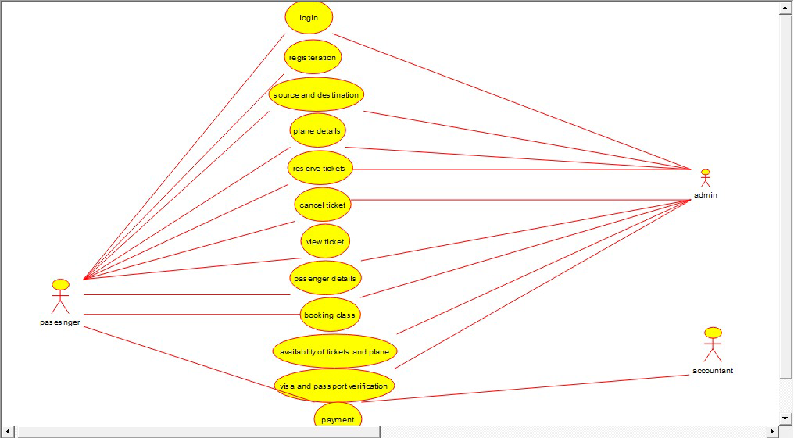

6. Draw a Class diagram for Online Airline Reservation System using CASE tools

